

MES Traceability Solution

Microtek International Pvt. Ltd.

Software Requirement Specification (SRS)
Project ID:
BAR CODE INDIA, 145 Udyog Vihar Phase 1, Gurugram, Haryana-122016, PH: 0124 4337555

Prepared By: Leena
Submission Date:
Version: 1.0
The document details the summary of solution architecture and approach for the development of MES Traceability Solution for Microtek International Pvt. Ltd. The document is based on the inputs, system study, discussions and meeting held between BCI & Microtek International Pvt. Ltd Teams.

Identification Operations

Trolley Identification
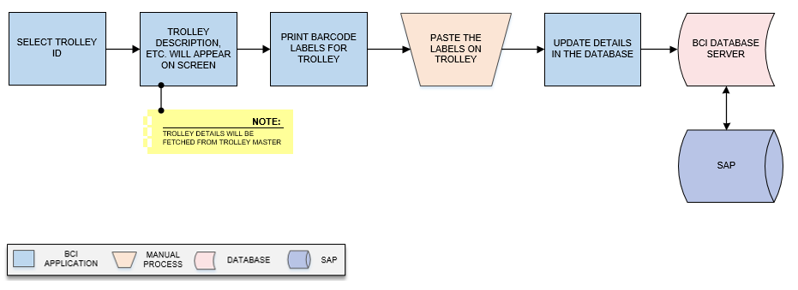
Activities
Module Description | This module will be used to provide unique identification to the each Trolley by printing barcode labels for them and save the details in the database  *This activity will be done using Device Application.

Pre-Conditions | - Pallet master should be available. (Do we need to create a master that will save Trolley data?)  - Trolley details should be saved.

Process Steps | - Select Trolley ID from dropdown list.  - Corresponding Trolley details such as Description, etc. (Suggest any) will appear on screen.  *Trolley details will be fetched from Trolley Master.  - Print barcode labels against selected Trolley.  - Paste labels on Trolley.  - Update details in database.

Post-Conditions | - Printing details will get saved in the database.

Validations | - An alert should be displayed in case duplicate Trolley data is entered.  - An alert should be displayed in case Trolley Barcode label is not printed

Inventory Replenishment (Bin – Component Mapping)
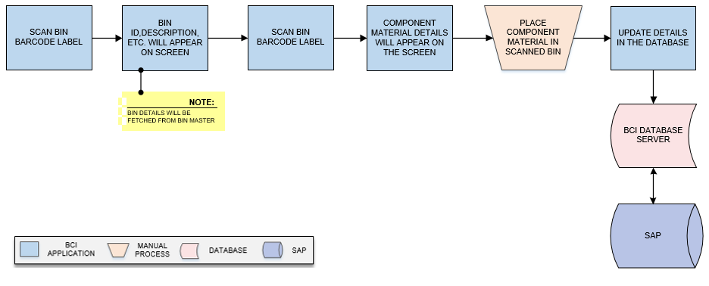
Activities
Module Description | This module will help user to map RM Components with the Bin and updating details in the database. This will help in validating data at the time of Bin issuance to Shop Floor. Components could be MSL Components.  *This activity will be done using Web Application.

Pre-Conditions | - Bin master should be available.

Process Steps | - Scan Bin Barcode Label.  - Bin details such as Bin ID, Active status, Description, etc. will appear on screen.  *Bin details will be fetched from Bin Master.  - Scan Component Material barcode label.  - Component Material details will appear on the screen. (Kindly suggest which details are given on component pack barcode label)  - Place Component material in scanned Bin.  - Update Bin – Component mapping details in the database.

Post-Conditions | - Mapping details will get updated in database.

Validations | - An alert should be displayed in case duplicate/ invalid barcode label is scanned.  - An alert should be displayed in case of invalid activity.

Stencil Inventory
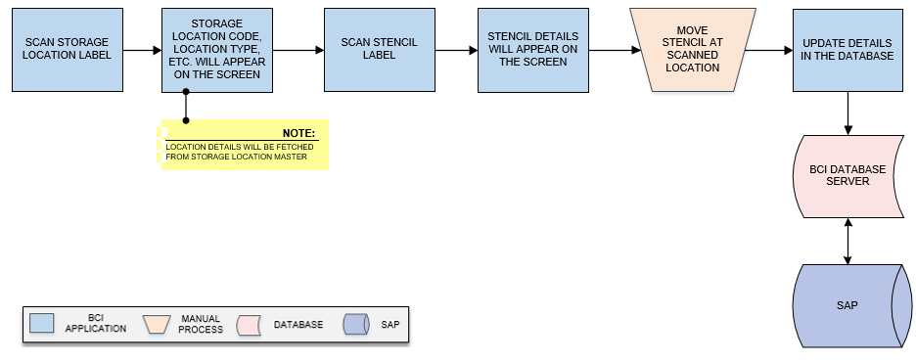
Activities
Module Description | This module will help user in keep track and record the Stencil used for Solder Paste Printing process. In this module Stencil is mapped with a storage location and Stencil Inventory will be saved in the database.  *This activity will be done using Device Application.

Pre-Conditions | - Storage Location master should be available

Process Steps | - Scan Storage Location label.  - Location details such as Storage Location Code, Location Type, etc. will appear on the screen.  *Location details will be fetched from Storage Location Master.  - Scan Stencil label.  - Stencil details such as (kindly suggest the Stencil details) will appear on the screen.  - Move stencil at scanned location.  - Update Stencil – Location mapping detail in the database.

Post-Conditions | - Stencil mapping location will get updated in database.

Validations | - An alert should be displayed in case duplicate Location data is updated.  - An alert should be displayed in case Stencil label is not scanned.  - An alert should be displayed in case of invalid activity.

